# How to create a new ZERO-COPY Signal Processing Node

## Step I: Copy working project

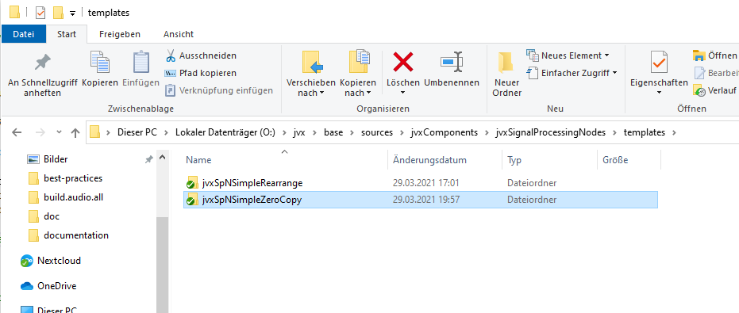

## Step II: Rename all files and folders

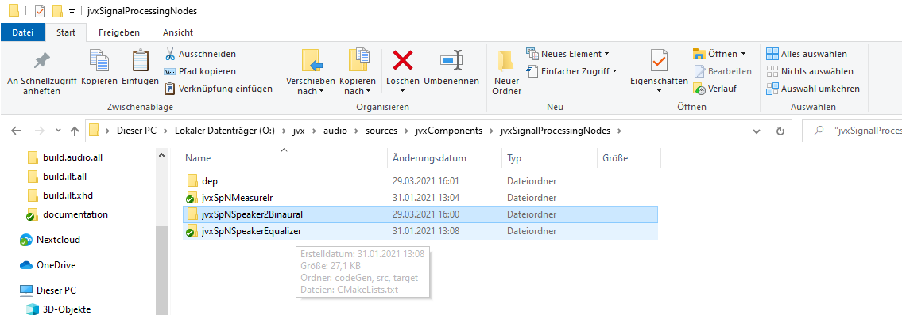

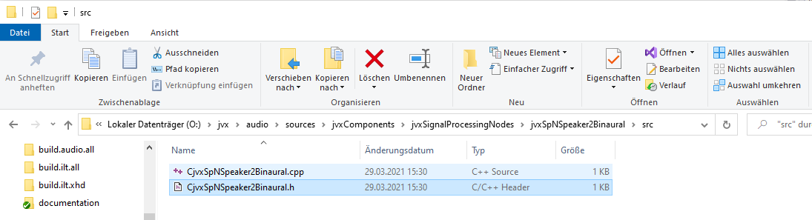

## Step III: Modify CMakeLists.txt to define a new project

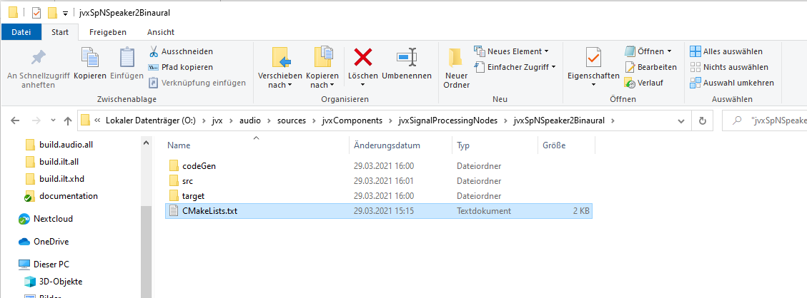

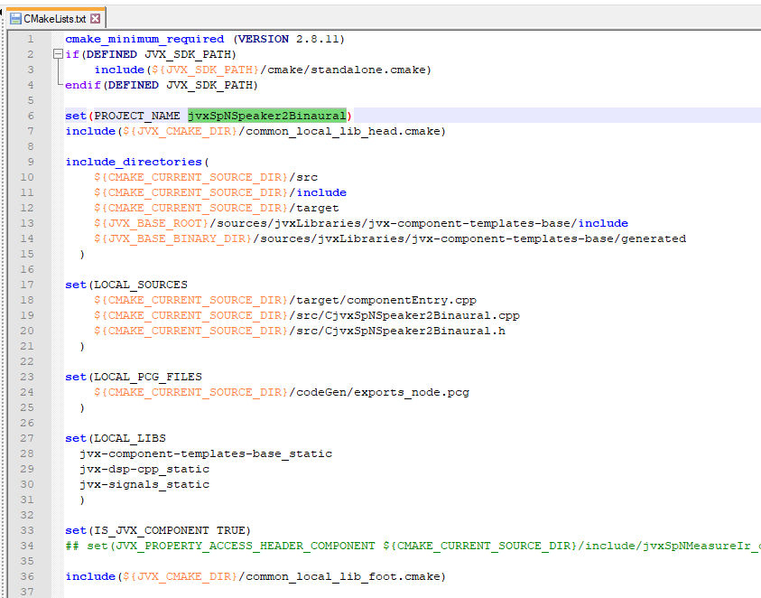

## Step IV: Reference the souce code files

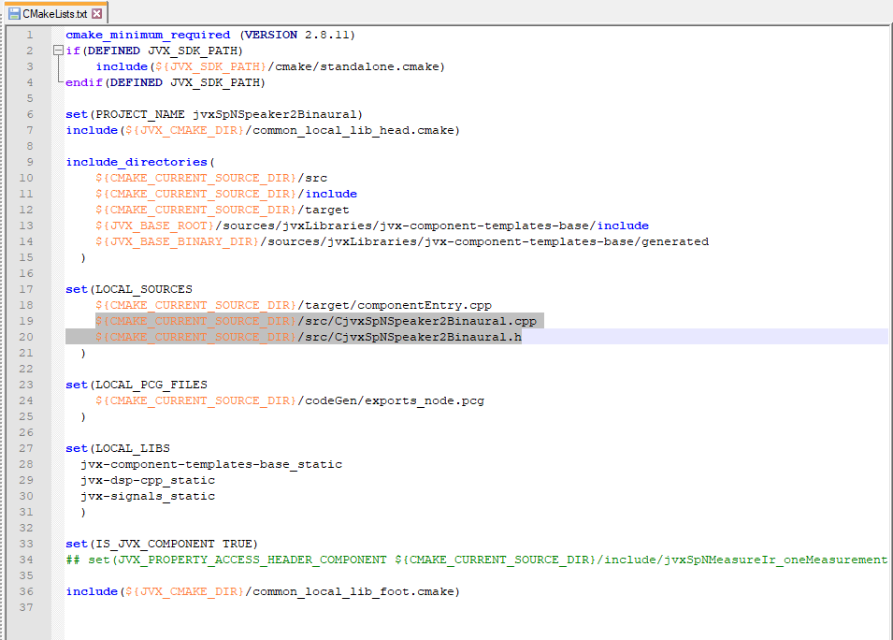

## Step V: Modify the project build files to integrate the new component

## 

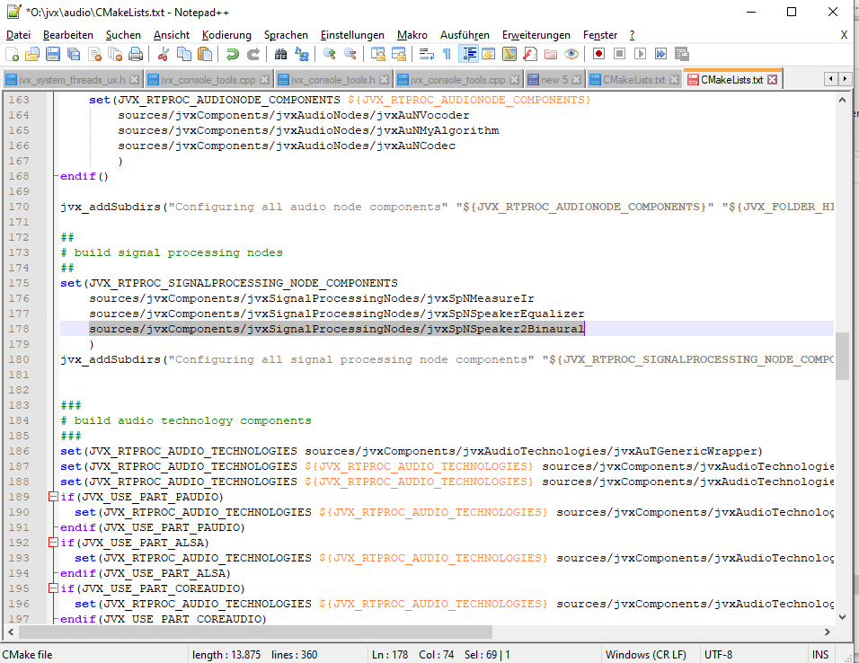

## Step VI: Run project configuration

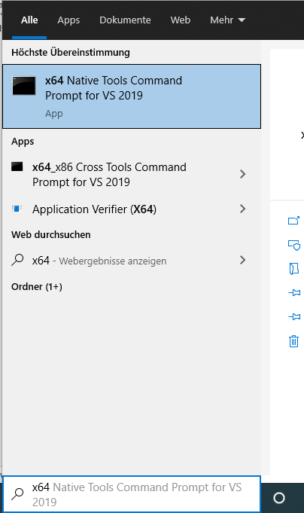

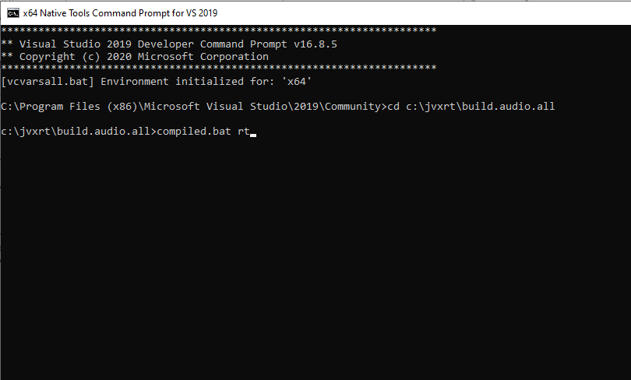

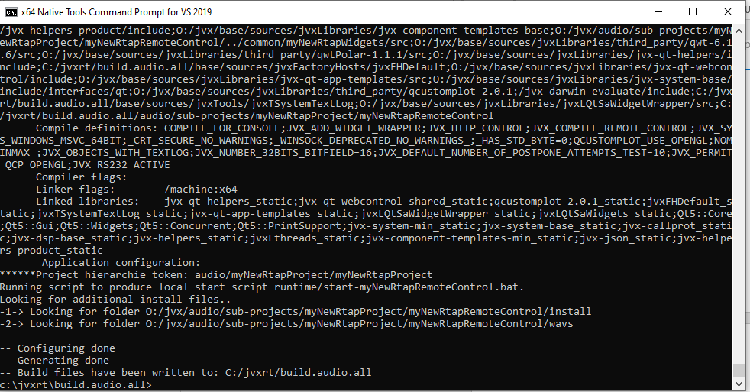

## Step VII: Re-open project in Visual Studio

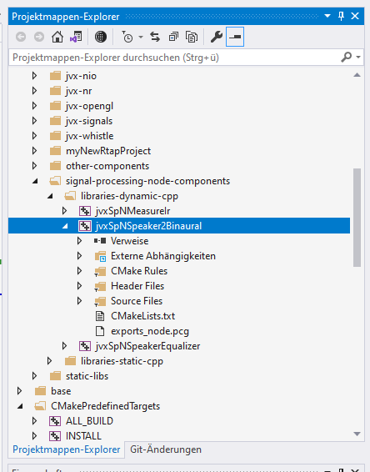

## Step VIII: First Build of the new project

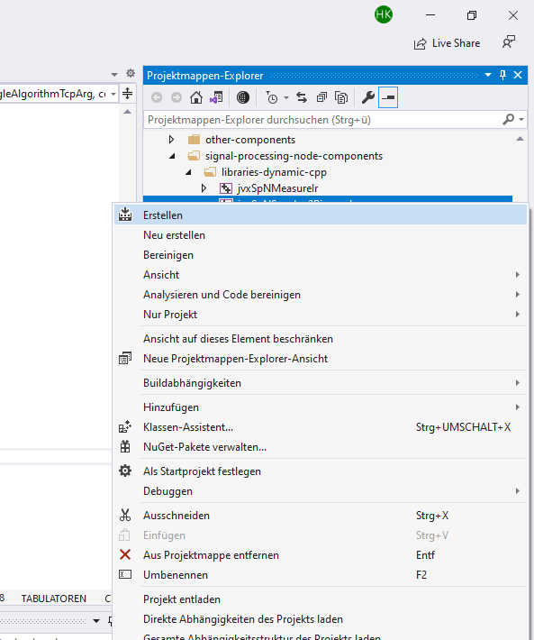

## Step IX: Adaptation of source code

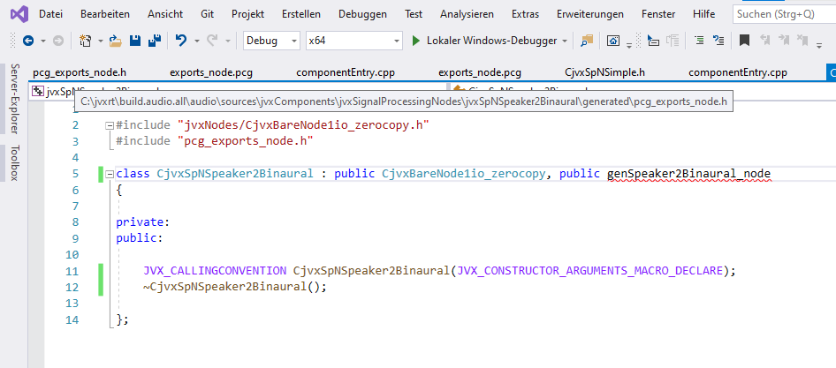

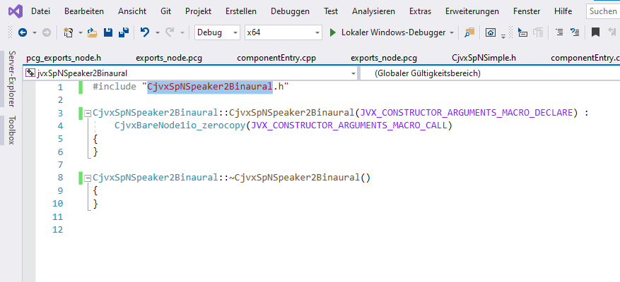

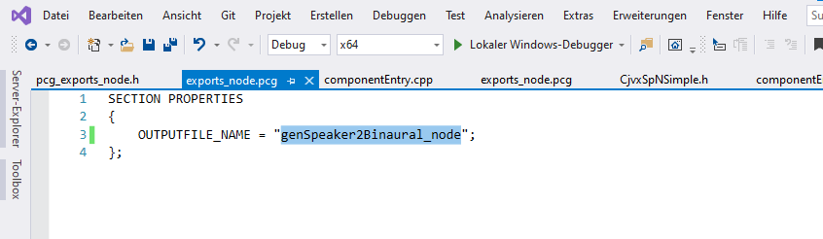

## Step X: Build the project with latest code adaptations

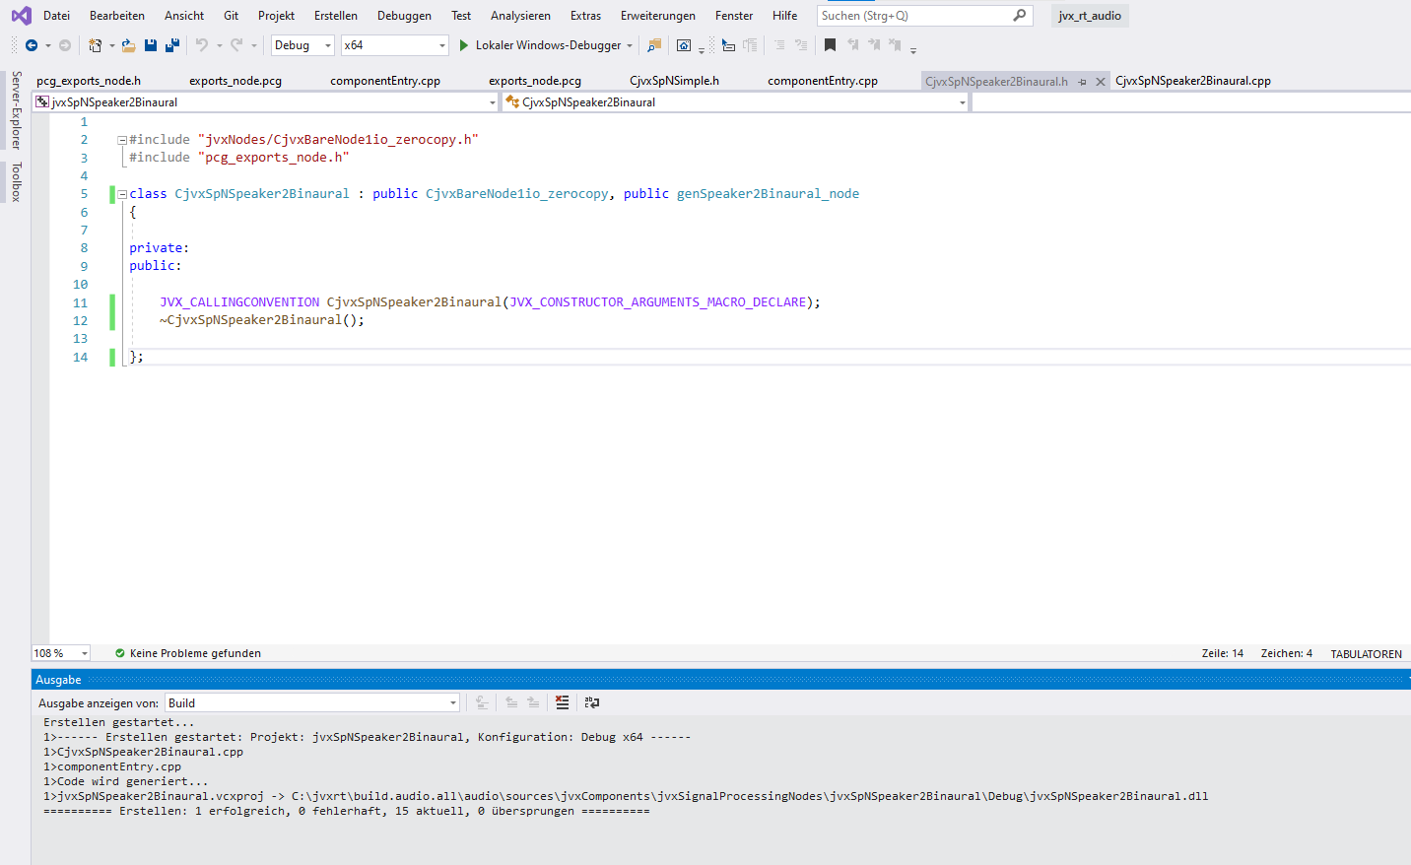

## Step XI: Configure behavior of base class

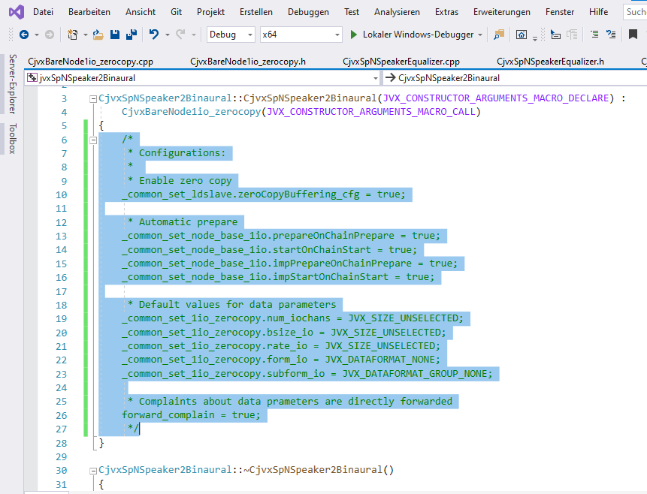

## Step XII: Activate Properties

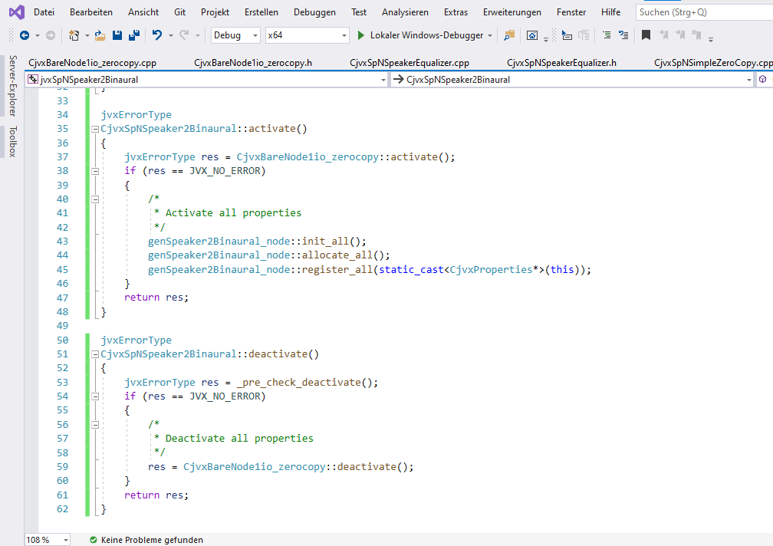

## Step XIII: Specify first property “bypass”

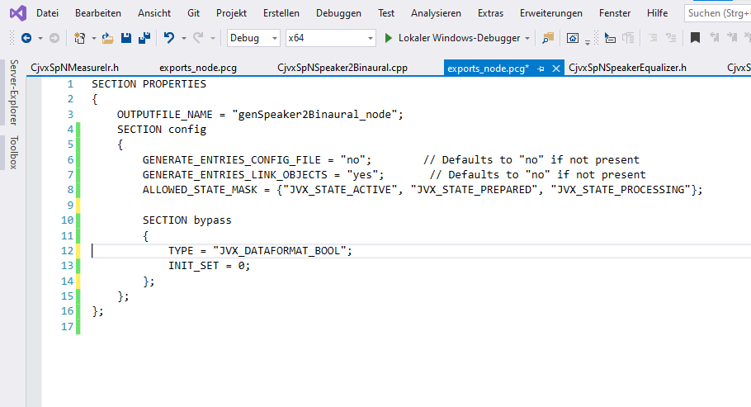

## Step XIV: Add storage of property in config file and callback to react to new property values

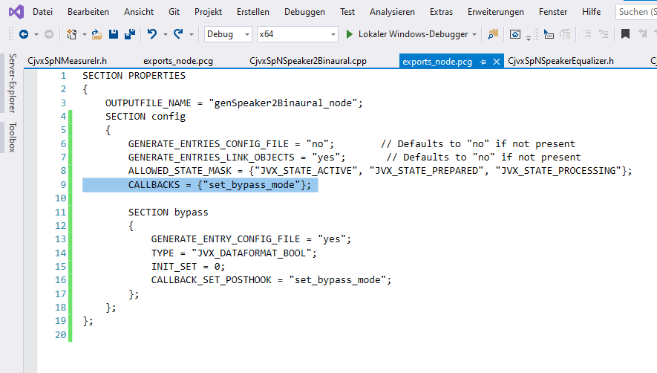

## Step XV: Implement callback for property on new value

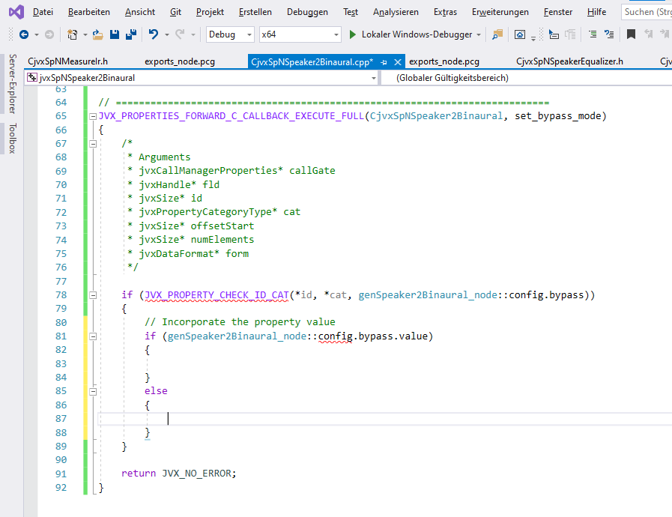

## Step XVI: Implement read/write of properties from /to configuration file

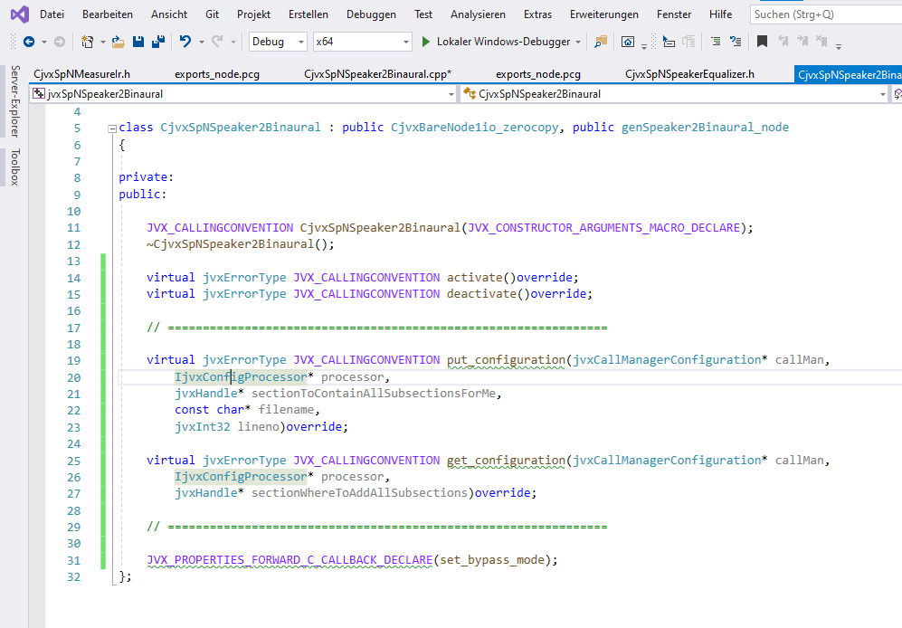

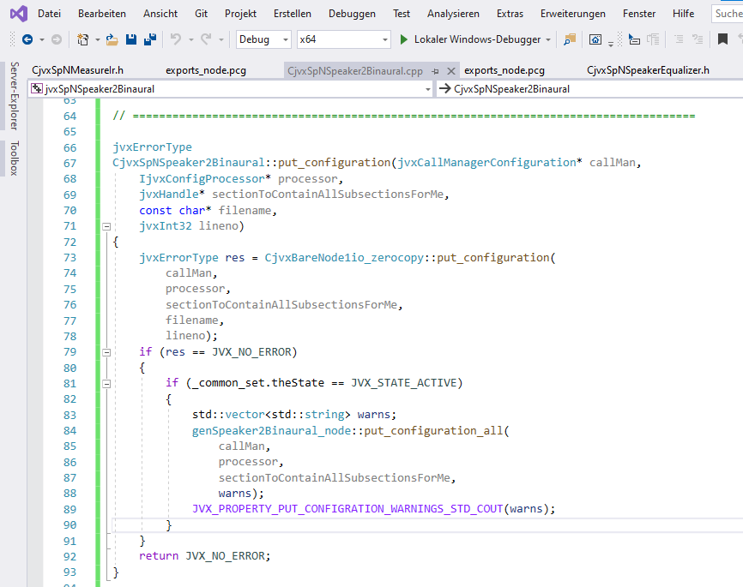

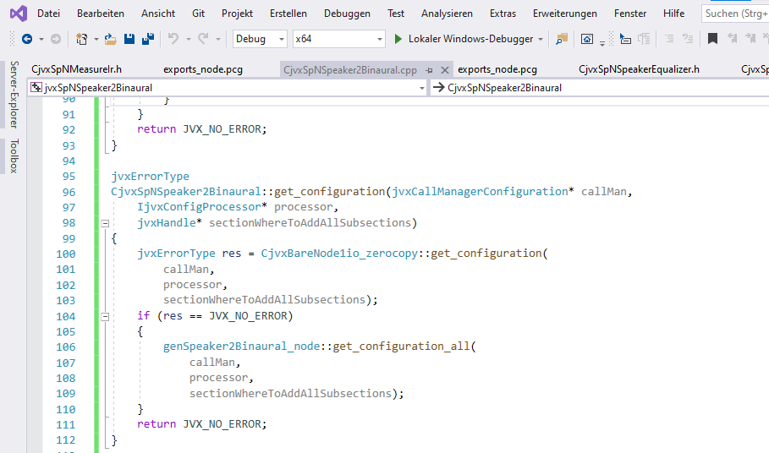

## Step XVII: Implement data processing callback

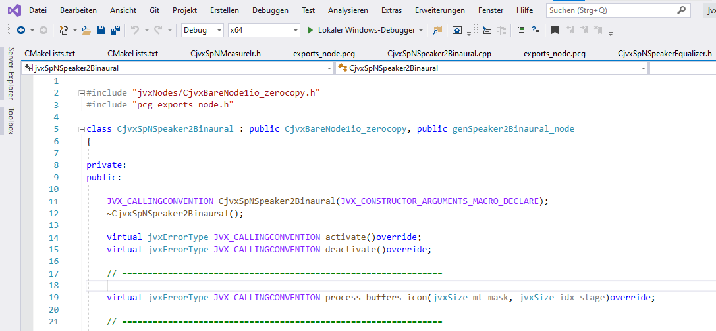

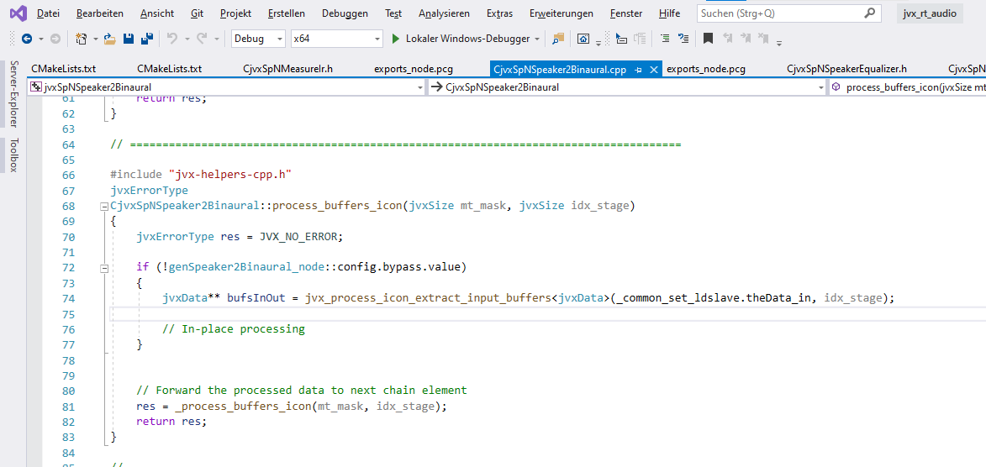

## Step XVIII: Add signal processing node to project executable, e.g. jvxUnrealRender

1. Add module to CMakeLists.txt: header include and library

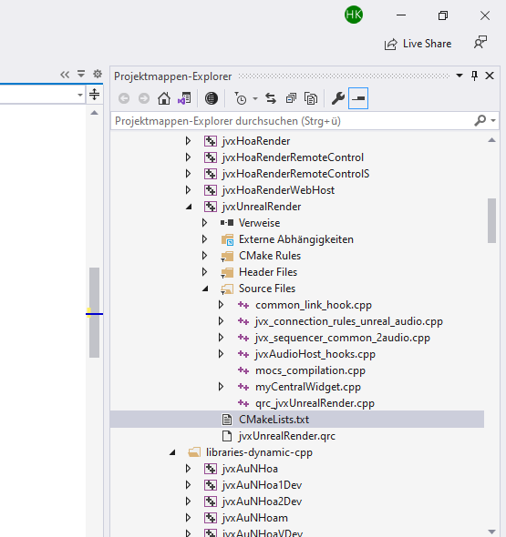

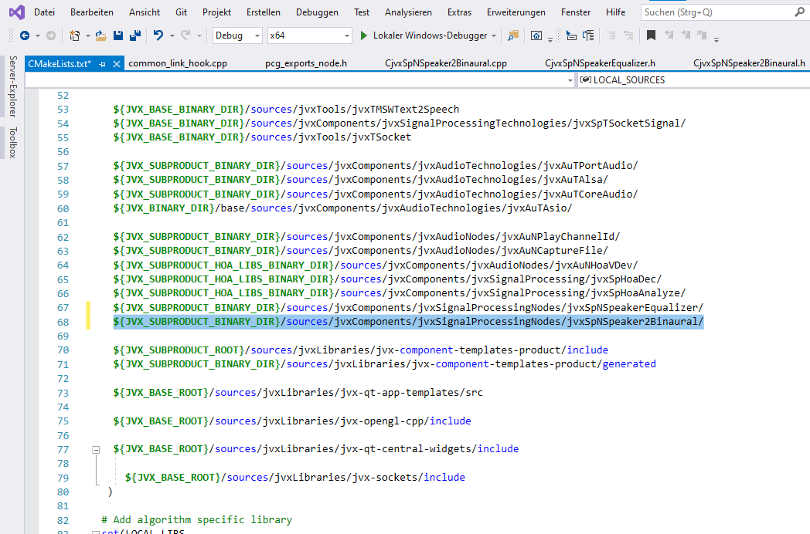

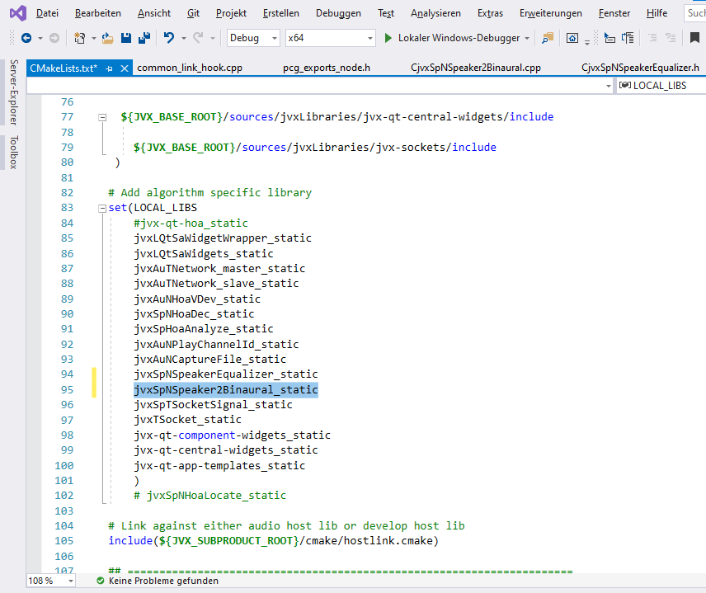

1. Add entry to hook to load component library at startup, include and code

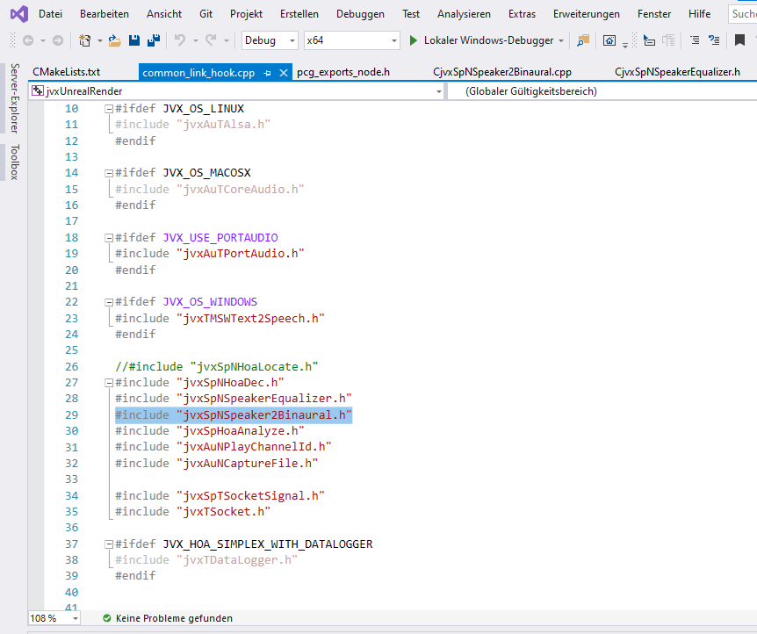

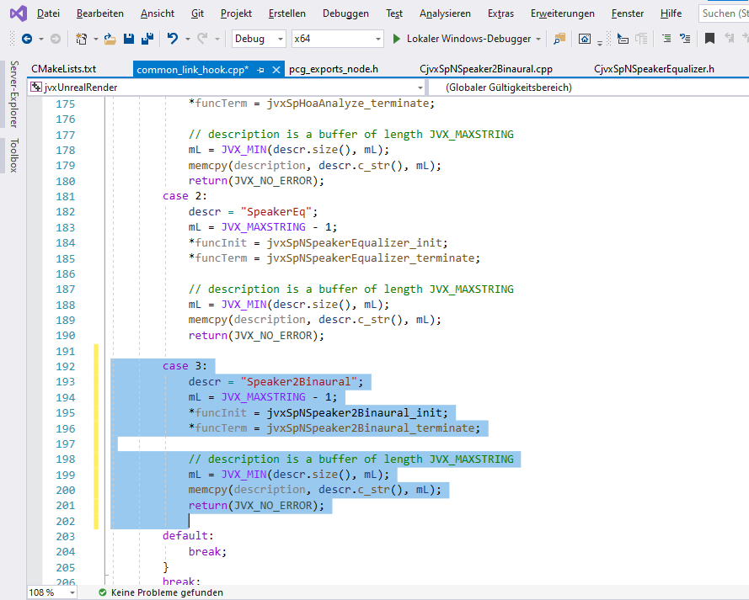

1. Add code to auto-start the new component, entry in table and number of slots

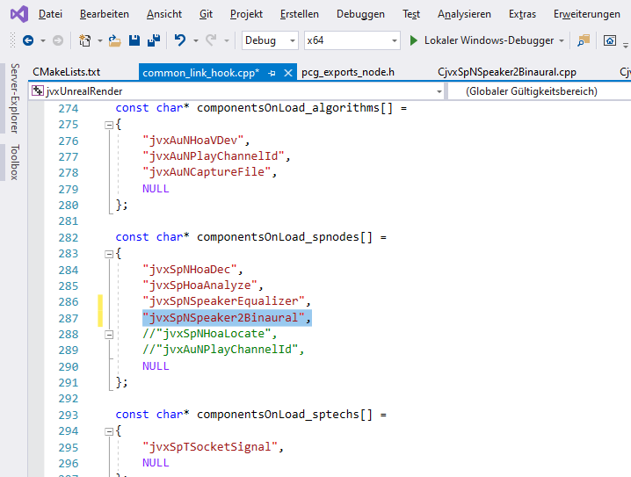

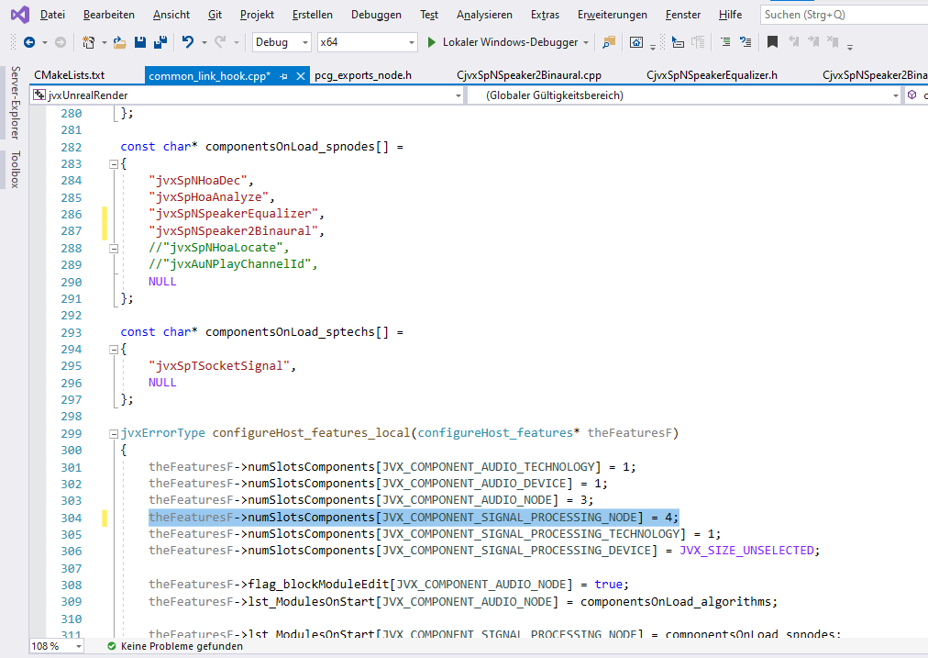

## Step XIX: Review the signal processing component

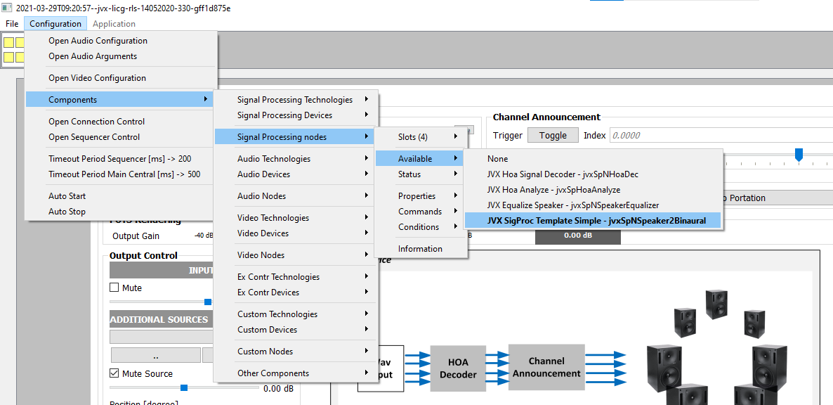

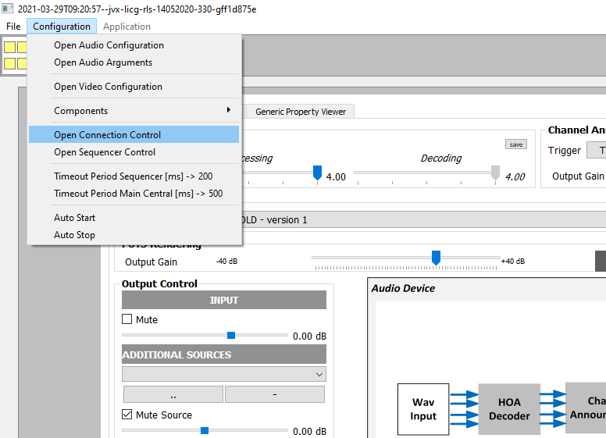

Component not yet involved in signal processing chain:

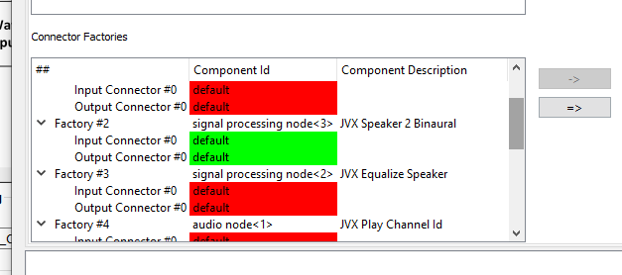

## Step XX: Extend connection to support binaural renderer

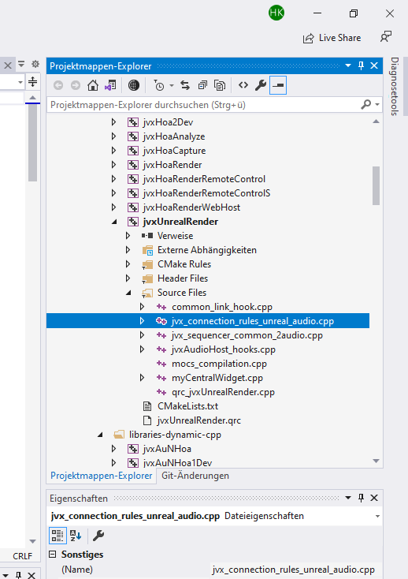

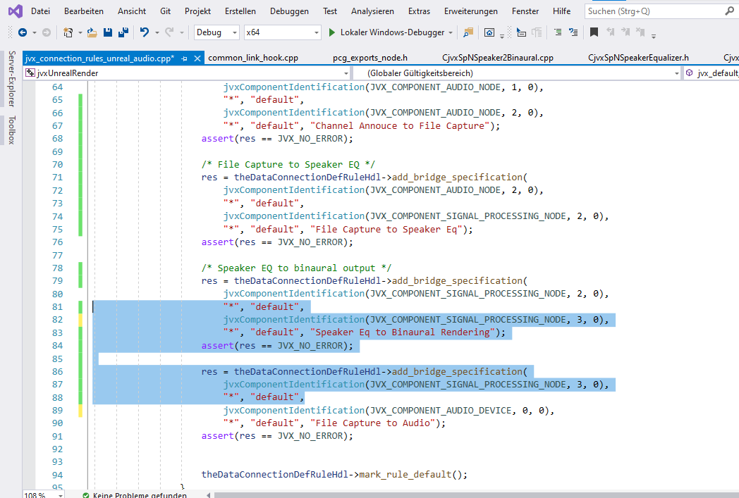

## Step XXI: Review of new connections

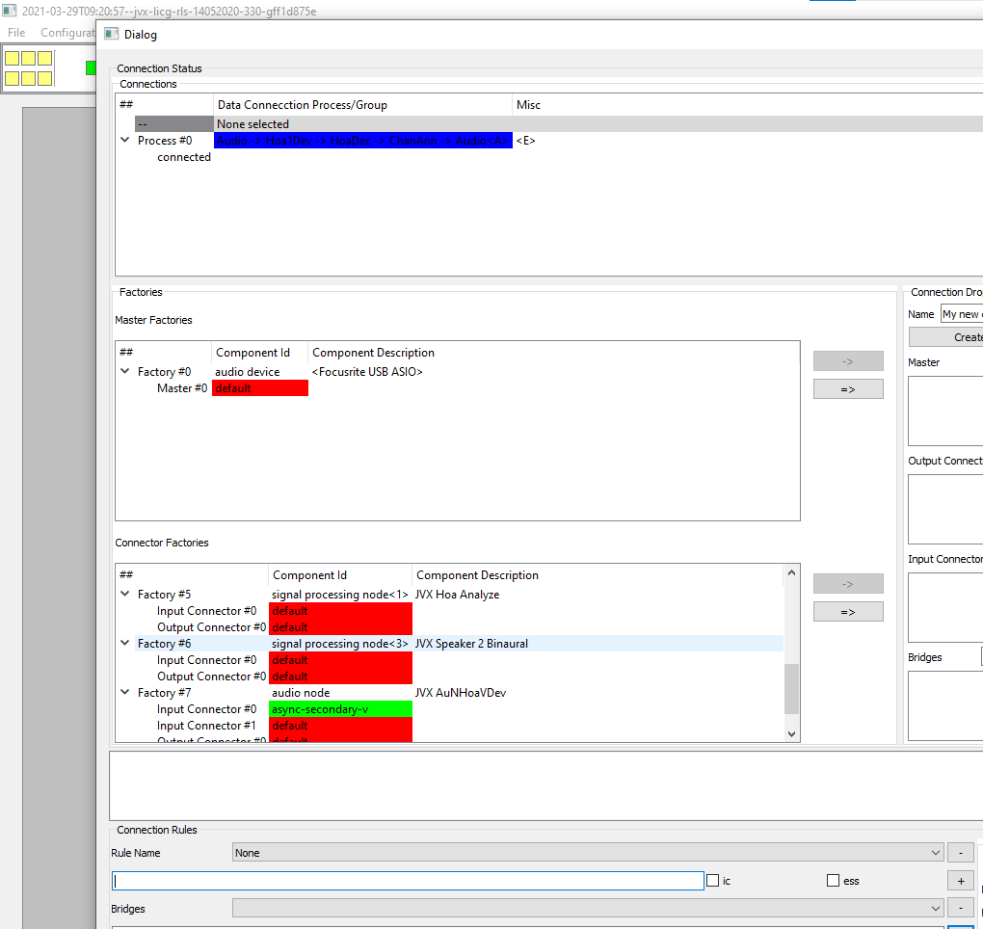

Review of the data flows

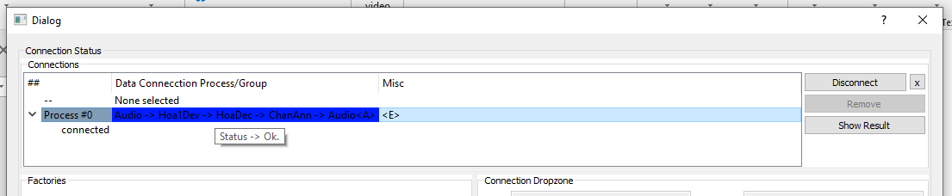

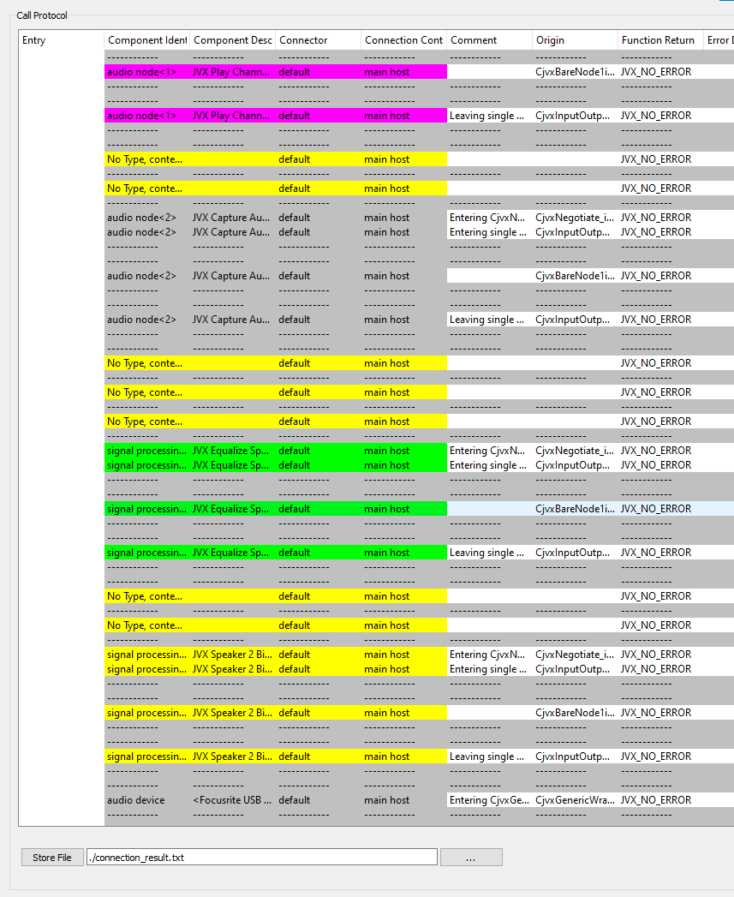

New component inserted right before output to audio device



## Step XXII: Review Connection Parameters

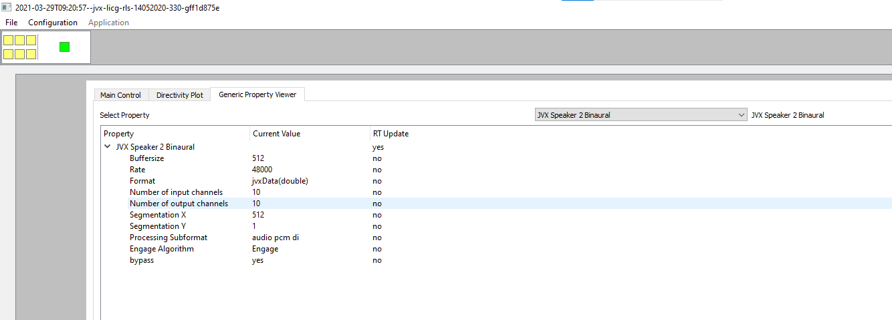

## Step XXIII: Run Processing with new component

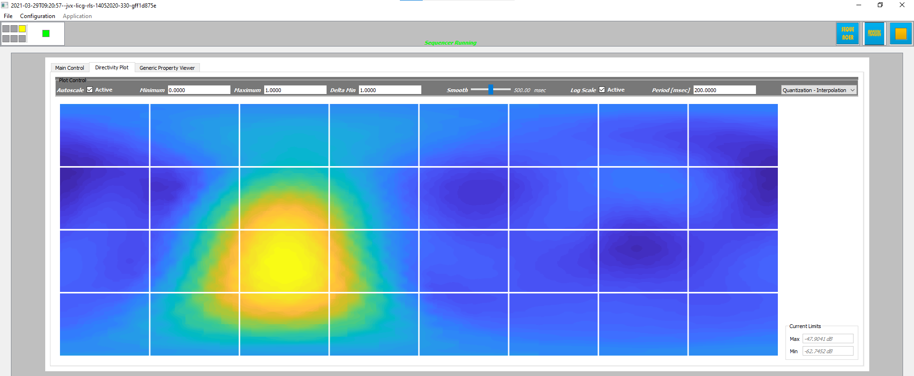

## Step XXIV: Debug Processing Function

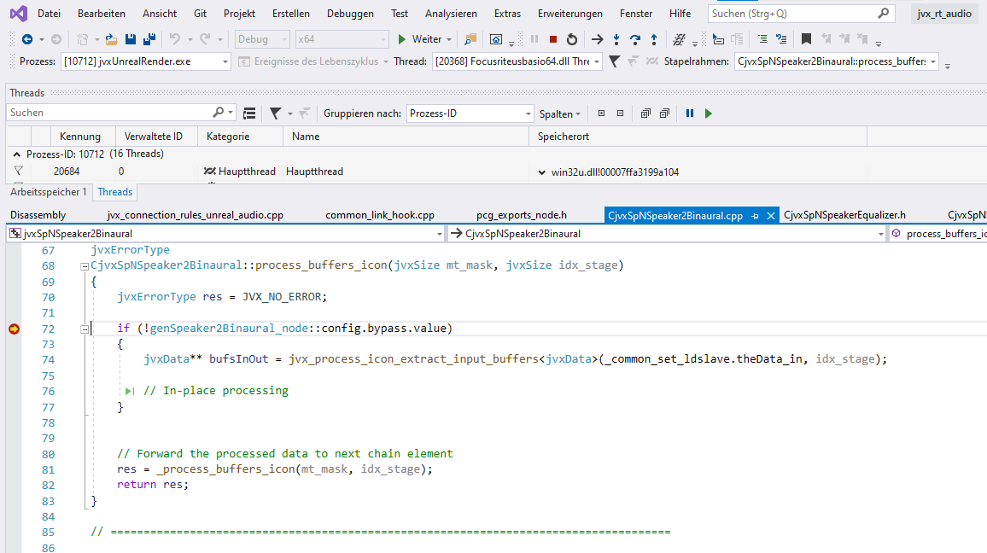

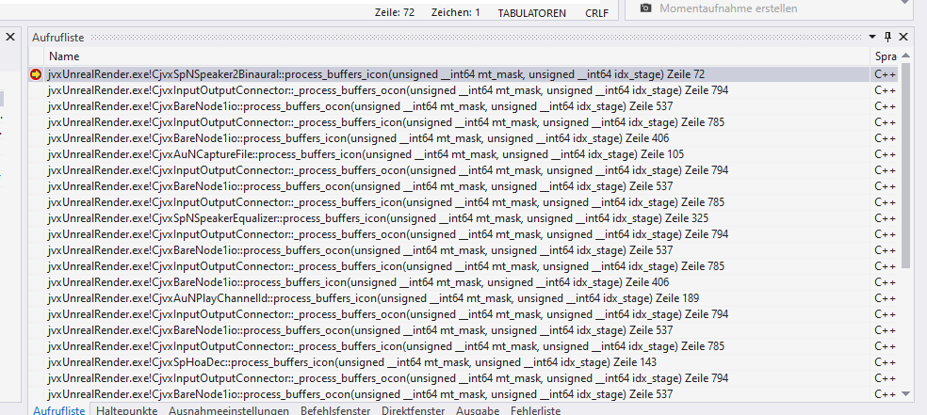

## Step XXV: Setup connection constraints

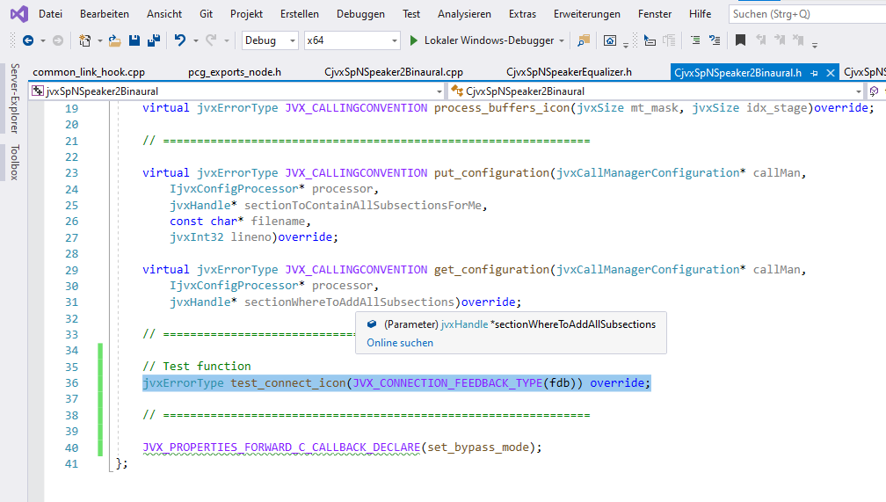

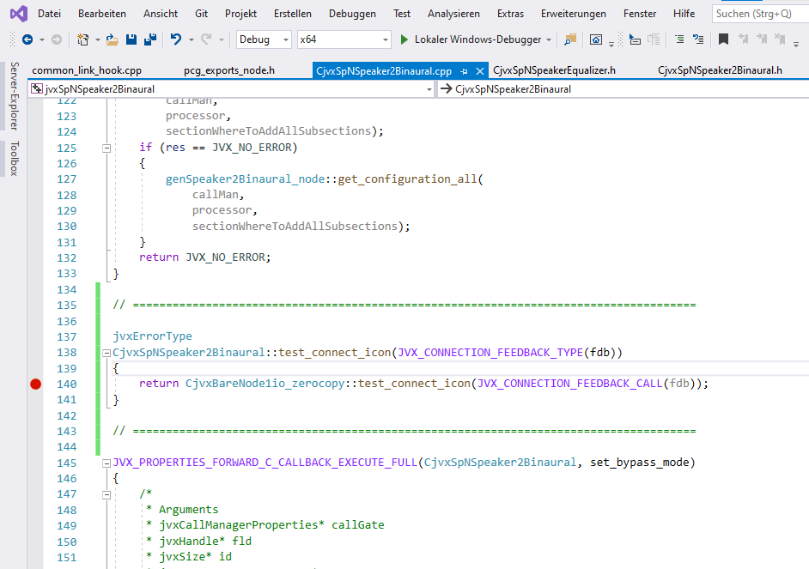

Default behavior: Input Parameters = Output Parameters (ZERO COPY MODULE!)

## Step XXVI: Deviate from default behavior: modify number of output channels

* Source Code to view:

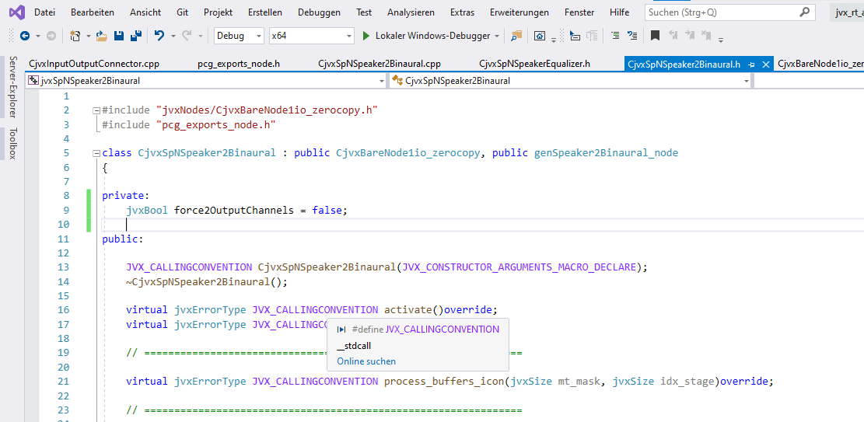

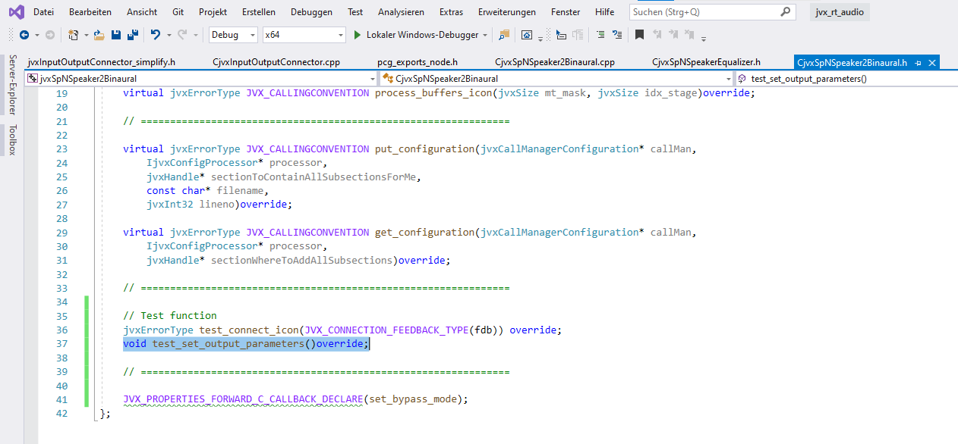

* Specify two output channels in specific mode – bool *force2OutputChannels*

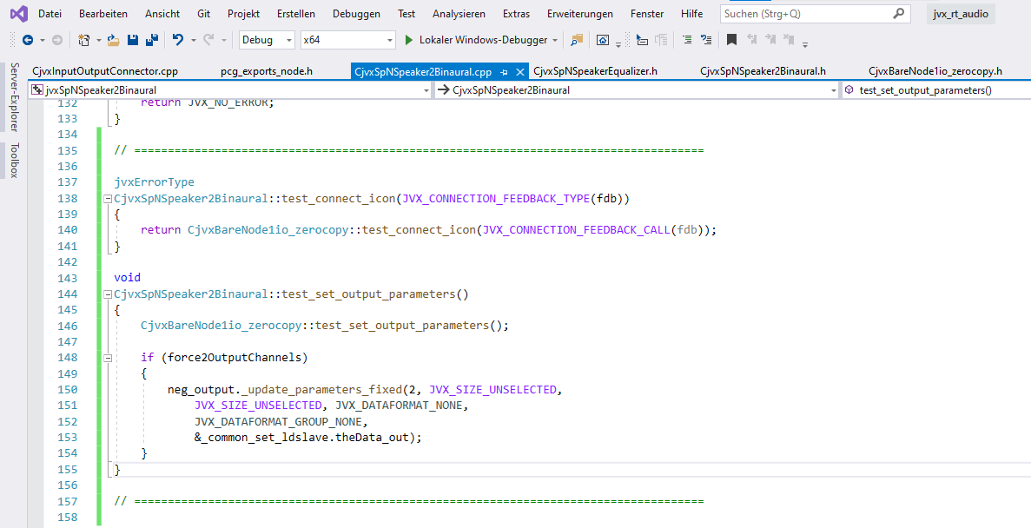

*neg_output* holds acceptable setting ranges whereas *_common_set_ldslave.theData_out* specifies a single, concrete value.

## Step XXVI: Make it configurable in UI: connect property

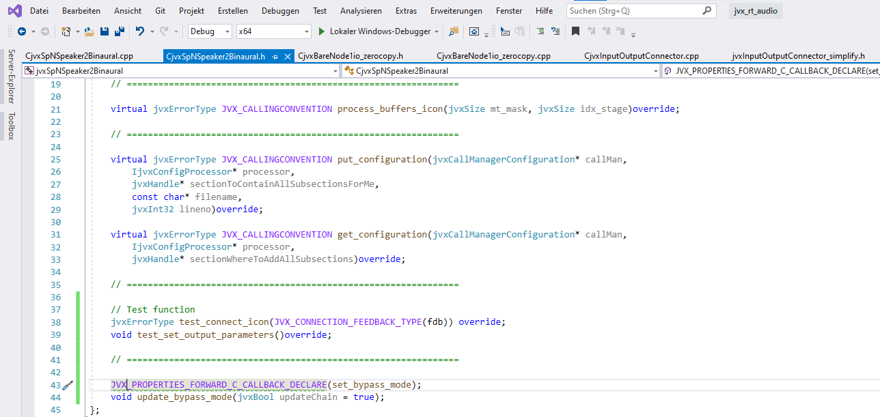

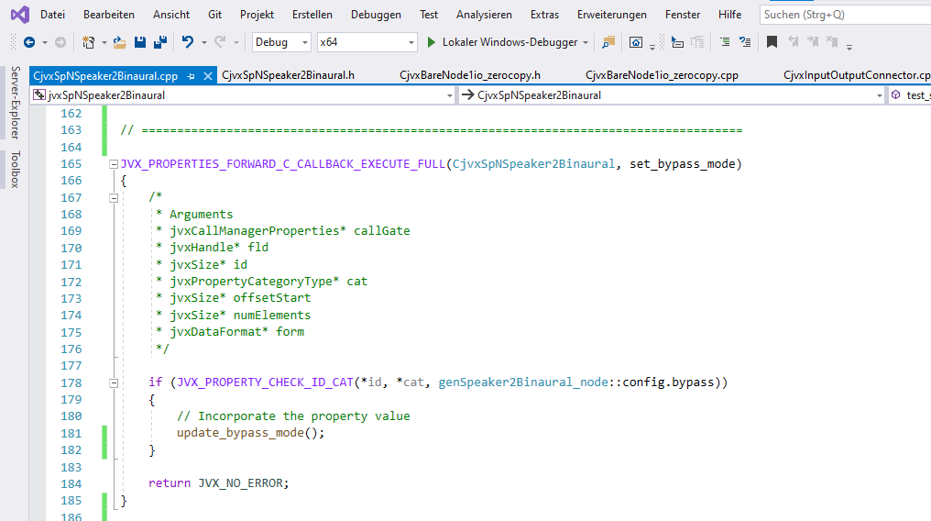

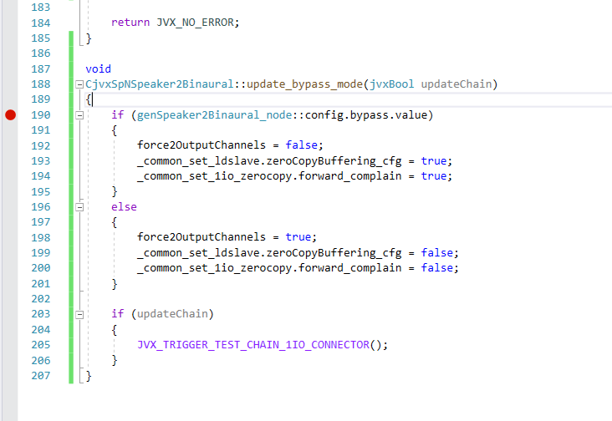

no zerocopy  
Format change (channel number) change in module

Bypass = zerocopy  
Parameter change with impact on successor

## Step XXVII: Test variable settings

Option 1: Bypass mode on:

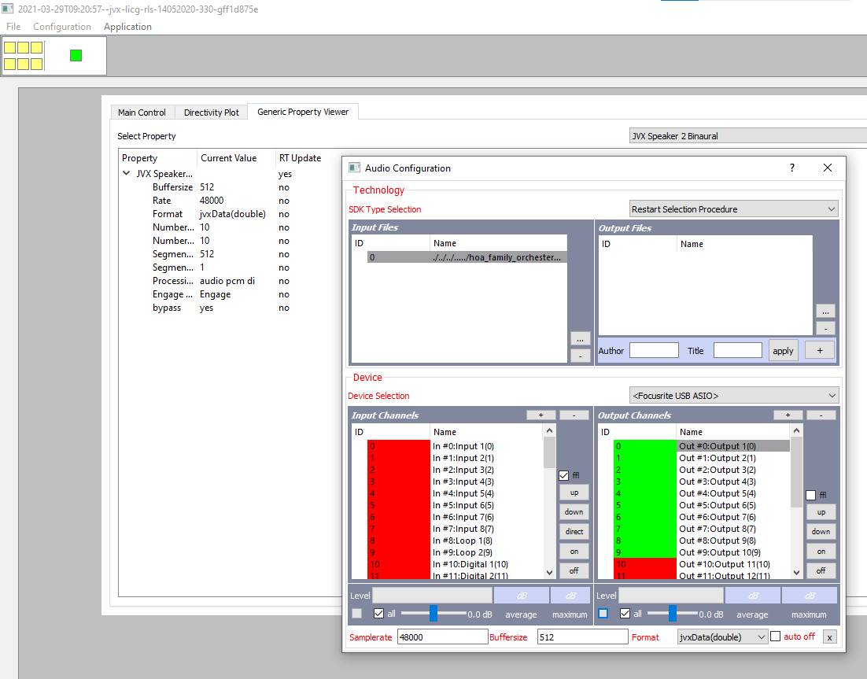

Option 1: Bypass mode off:

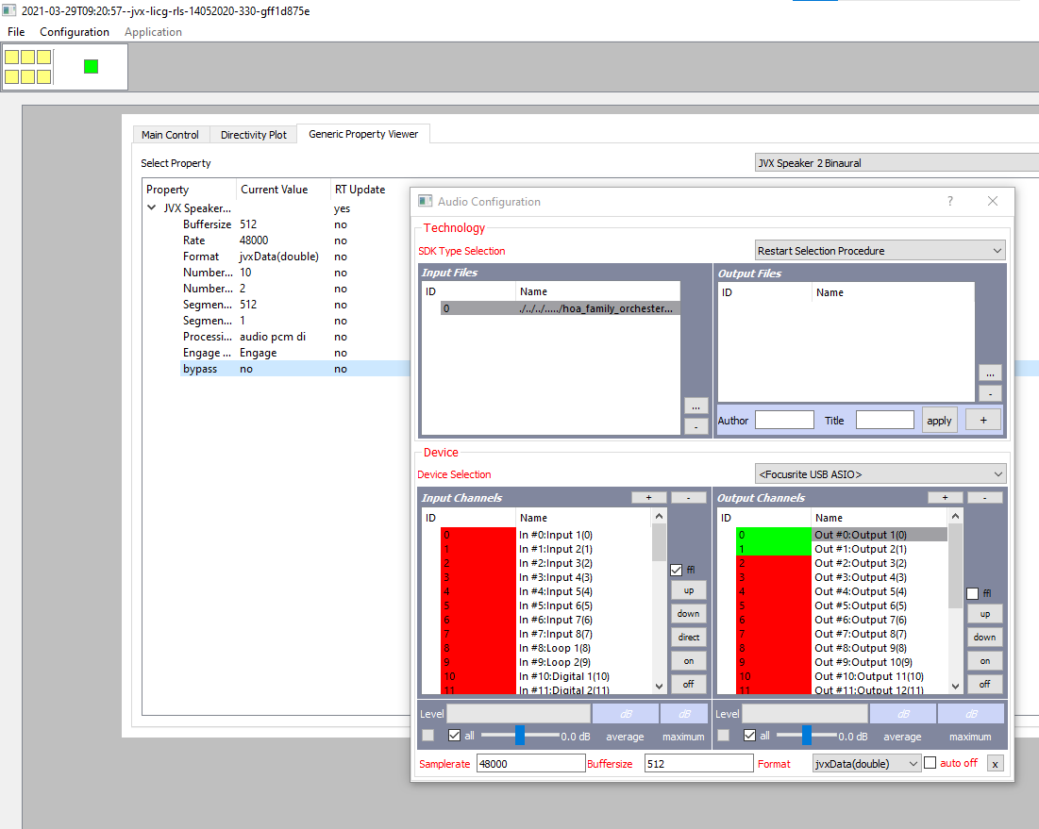

## Step XXVIII: Setup Data Processing

Indeed, this is not required since base class does everything already.

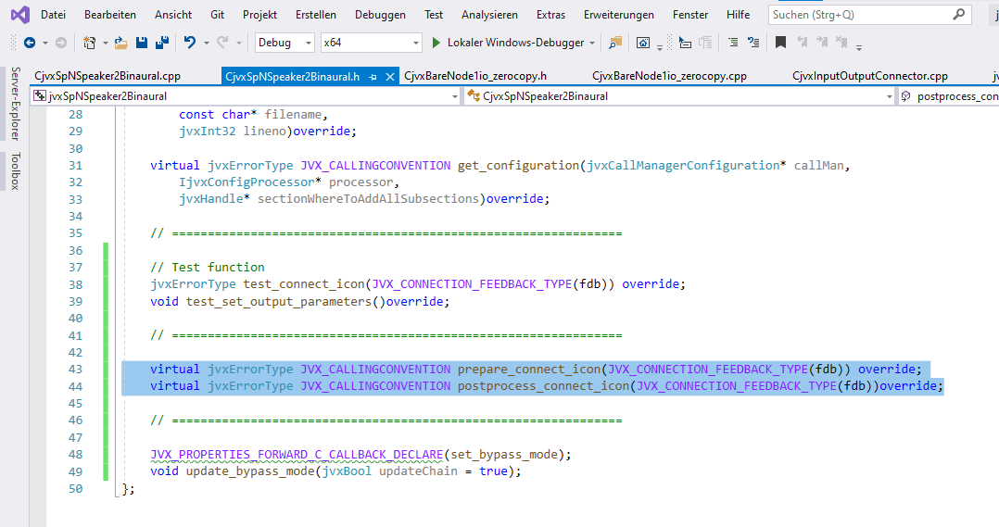

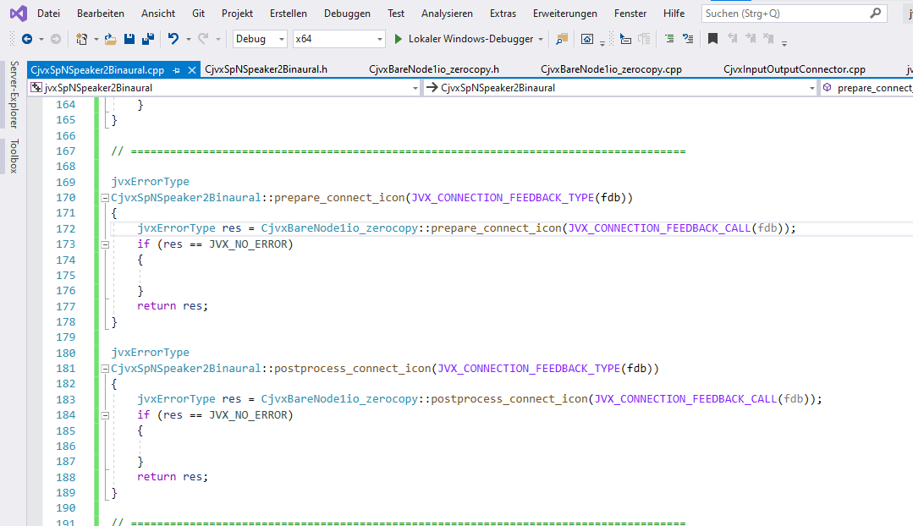

## Step XXIX: Implement signal processing

